BATCH: T5

PL-3 ASSIGNMENT NO. 1

**Study of Web and its basics**

NAME: Priti Sunil Desai

PRN NO. : 22510062

**Problem Statement 1:**

Q.1) Evolution of Web including web 3.0.

=>

Web 1.0

Web 1.0 is first generation of web and also known as informational web. It was all about fetching, and reading information. there are small amount of producer create web pages (interlinked) and a large number of customers access those web pages through browser via internet.

Features of web 1.0

* Easy to connect static pages with the system via hyperlinks
* Supports elements like frames and tables with HTML 3.2
* Also has graphics and a GIF button
* You can send HTML forms via mail

Drawbacks

* its slow and chunky nature and every time when new information entered to the web pages, it needs to be refresh every time.
* Less interaction between the user and the server
* Web1.0 doesn’t support two-way communications. It provides only a one-way publishing medium.

Web1.0 relied on old software business model.

Web 2.0

Web 2.0 is all about reading, writing, creating, and interacting with the end user. It was famously called the participative social web.

Features of web 2.0

* Free sorting of information, permits users to retrieve and classify the information collectively.
* Dynamic content that is responsive to user input.
* Information flows between the site owner and site users using evaluation & online commenting.
* Developed APIs to allow self-usage, such as by a software application.
* Web access leads to concerns different, from the traditional Internet user base to a wider variety of users.

Web 3.0

Web 3.0 is all about reading writing and executing also called as semantic web.

* Read-write-interact web
* Powered by blockchain
* The use of decentralized network provides data control of owners
* 3D visuals and graphics
* Uses artificial intelligence (AI) to provide fast results with accurate real-time insights
* Support for semantic web that understands the meaning of words
* Use of advanced authorization mechanisms for the protection of user data and identity

Q.2) Which ports and protocols are used by web? Describe those in detail.

* **Ports**

**1)Port 80**

Protocol: HTTP (HyperText Transfer Protocol)

Port 80 is the default port used by HTTP. It is responsible for transmitting web pages over the internet in an unencrypted format. When a user accesses a website using http://, the request is sent to port 80.

Use : Basic web browsing for non-secure websites.

**2) Port 443**

Protocol: HTTPS (HyperText Transfer Protocol Secure)

Port 443 is the default port used by HTTPS. HTTPS is the secure version of HTTP, encrypting data exchanged between the web server and the client using SSL/TLS protocols. When a user accesses a website using https://, the request is sent to port 443.

Use : Secure web browsing, online banking, e-commerce, and any situation where data privacy is critical.

**3) Port 53**

Protocol: DNS (Domain Name System )

DNS is an essential process for the modern Internet; it matches human-readable domain names to machine-readable IP addresses, enabling users to load websites and applications without memorizing a long list of IP addresses.

Use: Domain name resolution, enabling users to access websites using domain names instead of IP addresses.

* **Protocols**

1. **HTTP** (HyperText Transfer Protocol)

HTTP is an application-layer protocol for transmitting hypermedia documents, such as HTML. It is the foundation of data communication on the World Wide Web. HTTP is a stateless protocol, meaning each request from a client to server is independent and unrelated to previous requests.

**2)HTTPS** (HyperText Transfer Protocol Secure)

HTTPS is the secure version of HTTP, incorporating SSL/TLS to encrypt the data exchanged between the client and server. This ensures data integrity, confidentiality, and authenticity.

Key Features:

* Encryption: Protects data from eavesdroppers.
* Authentication: Ensures the server's identity.
* Data Integrity: Ensures data is not altered in transit.

**3)DNS** (Domain Name System)

DNS is a hierarchical and decentralized naming system for computers, services, or any resource connected to the internet or a private network. It translates human-readable domain names to machine-readable IP addresses.

**4) TCP** (Transmission Control Protocol)

TCP is a core transport-layer protocol that provides reliable, ordered, and error-checked delivery of a stream of data between applications running on hosts communicating via an IP network.

Reliable data transmission for web traffic, email, file transfer, etc.

**5) UDP** (User Datagram Protocol)

UDP is a transport-layer protocol that provides a simpler, connectionless communication model with minimal protocol mechanisms. It is used when speed is more critical than reliability.

Q.3 ) Difference Between HTTP & HTTPS.

|  |  |  |
| --- | --- | --- |
|  | **HTTP** | **HTTPS** |
| PORT | 1. HTTP uses port 80 by default | 1. HTTPS uses port 443 by default. |
| Security | 2. HTTP doesn’t encrypts data and provides server authentication | 2. HTTPS encrypts data and provides  server authentication |
| URL Prefix | 3. HTTP uses http:// | 3. HTTPS uses https:// |
| Speed | 4. Generally faster than HTTPS because it does not require the overhead of encryption and decryption. | 4. Slightly slower than HTTP due to the additional steps involved in encrypting and decrypting data. |
| Use | 5. HTTP is suitable for non-sensitive data transmission. | 5. HTTPS is necessary for any application where data security is a concern |
| Cost | 6. Free to implement as it does not require any certificates or additional infrastructure. | 6. Can involve costs for purchasing SSL/TLS certificates, though free options like Let’s Encrypt are available. |

Q.4) What is web developer tools and why it is needed?

Web developer tools, also called DevTools, are programs that allow professionals to create software and debug and test their code on web development projects. These tools also help individuals review the user interface of a web application or website. While these tools may not help developers build an application or website, they allow them to review the security and aesthetic features and design custom website elements.

They may be available to web developers as add-ons and built-in features in web browsers. When choosing a program, professionals may consider various factors, including ease of use, scalability, security, functionality and cost. These tools help developers create, test, debug, and optimize websites and web applications.

Exa. Figma, Django, React.js.

Need of web developer tools=>

1. Debugging: Identify Errors=> Quickly find and fix errors in HTML, CSS, and JavaScript.
2. Performance Optimization: Analyze the performance of web pages to find bottlenecks and improve load times.
3. Responsive Design: Simulate different devices and screen sizes to ensure that web pages are responsive and work well on all devices.
4. Security Testing: Check for security issues like mixed content, insecure cookies, and outdated SSL certificates.
5. SEO and Accessibility: Use tools like Lighthouse to audit web pages for SEO, performance, accessibility, and best practices.

Q.5) Elaborate with diagram client server architecture and MVC architecture. When to use which architecture?

**Client-server architecture**->

Client-server architecture is a computing model in which the server hosts, delivers, and manages most of the resources and services requested by the client. It is also known as the networking computing model or client-server network as all requests and services are delivered over a network. The client-server architecture or model has other systems connected over a network where resources are shared among the different computers.

Client-server architecture is arranged in a way that clients are often situated at workstations or on personal computers, while servers are located elsewhere on the network, usually on more powerful machines. Such a model is especially beneficial when the clients and server perform routine tasks. For example, in hospital data processing, a client computer can be busy running an application program for entering patient information, meanwhile, the server computer can be running another program to fetch and manage the database in which the information is permanently stored.

* Client and server machines typically require different hardware and software resources and come from other vendors.
* The network has horizontal scalability, which increases the number of client machines and vertical scalability, an then moves the entire process to more powerful servers or a multi-server configuration.
* One computer server can provide multiple services simultaneously, although each service requires a separate server program.
* Both client and server applications interact directly with a transport layer protocol. This process establishes communication and enables the entities to send and receive information.

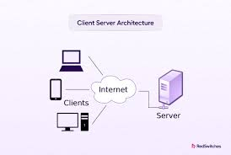

**MVC ARCHITECTURE**->

MVC is known as an architectural pattern, which embodies three parts Model, View and Controller, or to be more exact it divides the application into three logical parts: the model part, the view and the controller. It was used for desktop graphical user interfaces but nowadays is used in designing mobile apps and web apps.

**Model**

It is known as the lowest level which means it is responsible for maintaining data. Handle data logically so it basically deals with data. The model is actually connected to the database so anything you do with data. Adding or retrieving data is done in the model component.

**View**

Data representation is done by the view component. It actually generates UI or user interface for the user. So at web applications when you think of the view component just think the Html/CSS part.

**Controller**

It’s known as the main man because the controller is the component that enables the interconnection between the views and the model so it acts as an intermediary. The controller doesn’t have to worry about handling data logic, it just tells the model what to do.

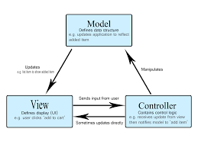

When to use->

The MVC pattern is helpful during the application's early design phase since it gives the developer a blueprint on how to turn their thoughts into code. It's also a great way to reduce code duplication and simplify application maintenance.

client-server networks are commonly used for data storage. The server can act as a central repository for files, databases, and other resources that need to be accessed and shared by multiple clients.

Q.6) What is HTML and HTML5?

->HTML stands for Hyper Text Markup Language. It is used to design web pages using a markup language. HTML is a combination of Hypertext and Markup language. Hypertext defines the link between the web pages. A markup language is used to define the text document within the tag which defines the structure of web pages.

Features of HTML:

* It allows the creation of hyperlinks with the <a> tag, connecting different web pages.
* Uses tags to mark elements and content, such as headings (<h1> to <h6>).
* It supports embedding images (<img>), videos (<video>), and audio (<audio>) for multimedia content.
* It provides form elements like <form>, <input>, and <button> for user input and data submission.
* Semantic tags like <article>, <section>, and <nav> for better document structure and accessibility.

->HTML 5is the fifth and current version of HTML. It has improved the markup available for documents and has introduced application programming interfaces(API) and Document Object Model(DOM). It has introduced various new features like drag and drop, geo-location services

Features of HTML5:

* Introduced new semantic elements like <header>, <footer>, <section>, and <article> for improved structure.
* Enhances multimedia capabilities with native support for audio and video elements.
* Provides the localStorage API, allowing web applications to store data locally on the user’s device.
* Enables websites to access a user’s geographical location.
* Uses SQL database to store data offline.

Q7) Which are the currently used versions of HTML and CSS for web development?

The latest version of HTML is HTML5, which stands for HyperText Markup Language. HTML5 enhances the capabilities of the web by introducing new elements, attributes, and behaviors. It allows for more dynamic and interactive web pages.

 CSS3 is the current version of CSS that implements new animation and transition properties, allows gradients, webfonts, advanced selectors and a few built in functions that differ greatly from CSS2.

Q.8) Which tools are available for front end development and back end development?

A Front-End Web Development Tool is actually the software that allows the front-end developers to build the website layout and UI more efficiently and without any hassle. With the help of such tools – the work of front-end web developers, especially the repetitive or monotonous tasks, gets reduced that subsequently fastens the web development process.  Ex.node.js,MangoDB.

There are numerous front-end web development tools out there for various specific requirements such as HTML, CSS, and JavaScript tools, Code-Editing tools, Deployment Tools, Prototyping & Wireframing tools, Security tools, and many more. Though you’re required to consider various factors before opting out for a particular tool such as your requirements (quite obvious it is!!), offered functionalities, ease of use, platform compatibility, prices, etc.  Ex.react.js.

Q.9) What MERN stack includes? Why and when it is preferred for web development?

=> The MERN stack is a popular web development framework that includes four key technologies:

**1)MongoDB**: A NoSQL database that stores data in JSON-like documents, offering flexibility and scalability.

**2)Express.js**: A web application framework for Node.js, designed for building web applications and APIs.

**3)React**: A JavaScript library for building user interfaces, particularly single-page applications.

**4)Node.js**: A runtime environment that allows executing JavaScript code server-side, enabling the development of scalable network applications. 5

MERN is preferred due to=>

1. **Full-Stack JavaScript**: All components of the MERN stack use JavaScript, which means developers can use the same language for both client-side and server-side development, streamlining the development process and reducing context switching.

2. **Efficiency**: The stack offers a seamless development process from front-end to back-end. Using JavaScript throughout the stack enables faster development and easier debugging.

3. **Scalability**: MongoDB offers horizontal scalability, Node.js handles asynchronous operations efficiently, and React facilitates building dynamic user interfaces, making the stack suitable for large-scale applications.

When to use=>

1) **Single-Page Applications (SPAs)**: The MERN stack is ideal for SPAs where the application is loaded once, and new data is fetched dynamically without refreshing the entire page.

2) **Real-Time Applications**: Applications that require real-time data updates, such as chat applications, live notifications, and collaborative platforms, benefit from Node.js's event-driven architecture.

3) **Cloud-Based Applications**: The stack's scalability and efficient data management make it suitable for cloud-based applications that need to handle large amounts of data and user interactions.

Q.10) List out newly introduced input types, APIs, form elements, and elements that support media content in HTML5.

1)**Newly Introduced Input Types in HTML5**=>

1) **color**: <input type="color">

2) **date**: <input type="date">

3) **datetime-local**: <input type="datetime-local">

4) **email**: <input type="email">

5) **month**: <input type="month">

6) **number**: <input type="number">

7) **range**: <input type="range">

8) **search**: <input type="search">

9) **tel**: <input type="tel">

10) **time**: <input type="time">

2)**Newly Introduced APIs in HTML5**=>

1) **Canvas API**: For drawing graphics on the web.

2) **Geolocation API**: To get the geographical position of a user.

3) **Local Storage and Session Storage**: For storing data on the client side.

4) **Web Workers**: For running scripts in background threads.

5) **Web Sockets**: For real-time communication between the client and server.

6) **File API**: For handling file uploads and manipulation.

7) **Drag and Drop API**: For enabling drag-and-drop functionality.

8) **History API**: For manipulating the browser history.

9) **IndexedDB**: For large-scale, client-side storage of structured data.

10) **Fullscreen API**: For displaying content in full-screen mode.

3)**Newly Introduced Form Elements in HTML5**=>

1) **datalist**: <datalist> - Provides a list of predefined options for an <input> element.

2) **output**: <output> - Represents the result of a calculation.

3) **progress**: <progress> - Displays the progress of a task.

4) **meter**: <meter> - Represents a scalar measurement within a known range

4) **Elements that Support Media Content in HTML5**=>

1) **audio**: <audio> - Embeds audio content.

2) **video**: <video> - Embeds video content.

3) **source**: <source> - Specifies multiple media resources for <audio> and <video> elements.

4) **track**: <track> - Specifies text tracks (such as subtitles) for <video> and <audio> elements.

5) **embed**: <embed> - Embeds external content.

Q.11) Explain HTML5 Web storage.

=> HTML5 Web Storage is a feature in modern web browsers that allows websites to store data on a user's device. This storage comes in two main types: local storage and session storage.

1)local storage

1.**Scope**: Local storage is per domain and accessible from any page within that domain.

2. **Lifetime**: The data persists even after the browser is closed and reopened. It remains until explicitly deleted.

3. **Storage Limit**: Typically around 5-10 MB per domain.

4. **Use Case**: Ideal for storing data that needs to be persisted across sessions, such as user preferences, settings, and application state.

2)session storage

1. **Scope**: Session storage is per window or tab and only accessible within the same window or tab that created it.

2. **Lifetime**: The data is deleted when the window or tab is closed.

3. **Storage Limit**: Generally smaller than local storage, typically around 5 MB per session.

4. **Use Case**: Suitable for temporary data that needs to be preserved only during a single session, such as form inputs and temporary state information.

**Problem Statement 2:**

Study of Different HTML and CSS tags:

1) Study different tags of HTML and CSS

**1)HTML Tags=>**

1) <h1> to <h6>: Header tags, with <h1> being the highest (most important) level and <h6> the lowest.

2) <p>: Paragraph tag.

3) <br>: Line break.

4) <strong>: Bold text (semantically strong).

5) <em>: Italic text (emphasis).

6) <b>: Bold text (no semantic meaning).

7) <i>: Italic text (no semantic meaning).

8) <u>: Underlined text.

9) <span>: Inline container for text, used for styling.

10) <ul>: Unordered list.

11) <ol>: Ordered list.

12) <li>: List item

13) <a>: Anchor tag, used for hyperlinks.

14) <img>: Image tag.

15) <video>: Video tag.

**2)CSS Properties=>**

1) width: Sets the width of an element.

2) height: Sets the height of an element.

3) margin: Sets the outer margin of an element.

4) padding: Sets the inner padding of an element.

5) border: Sets the border of an element.

6) box-shadow: Adds shadow to an element.

7) display: flex: Enables flexbox layout.

8) flex-direction: Sets the direction of the flex items (row, row-reverse, column, column-reverse).

9) justify-content: Aligns flex items along the main axis.

10) align-items: Aligns flex items along the cross axis.

11) flex-wrap: Sets whether flex items should wrap or not.

12) align-content: Aligns flex lines when there is extra space in the cross axis.

Q.2) Create a static web page for “Portfolio” of your own. Which will include photo, name, class, College name, Achievements/ Certificates, Extracurricular Activities, Courses Completed, hobbies, Technical expertise, etc

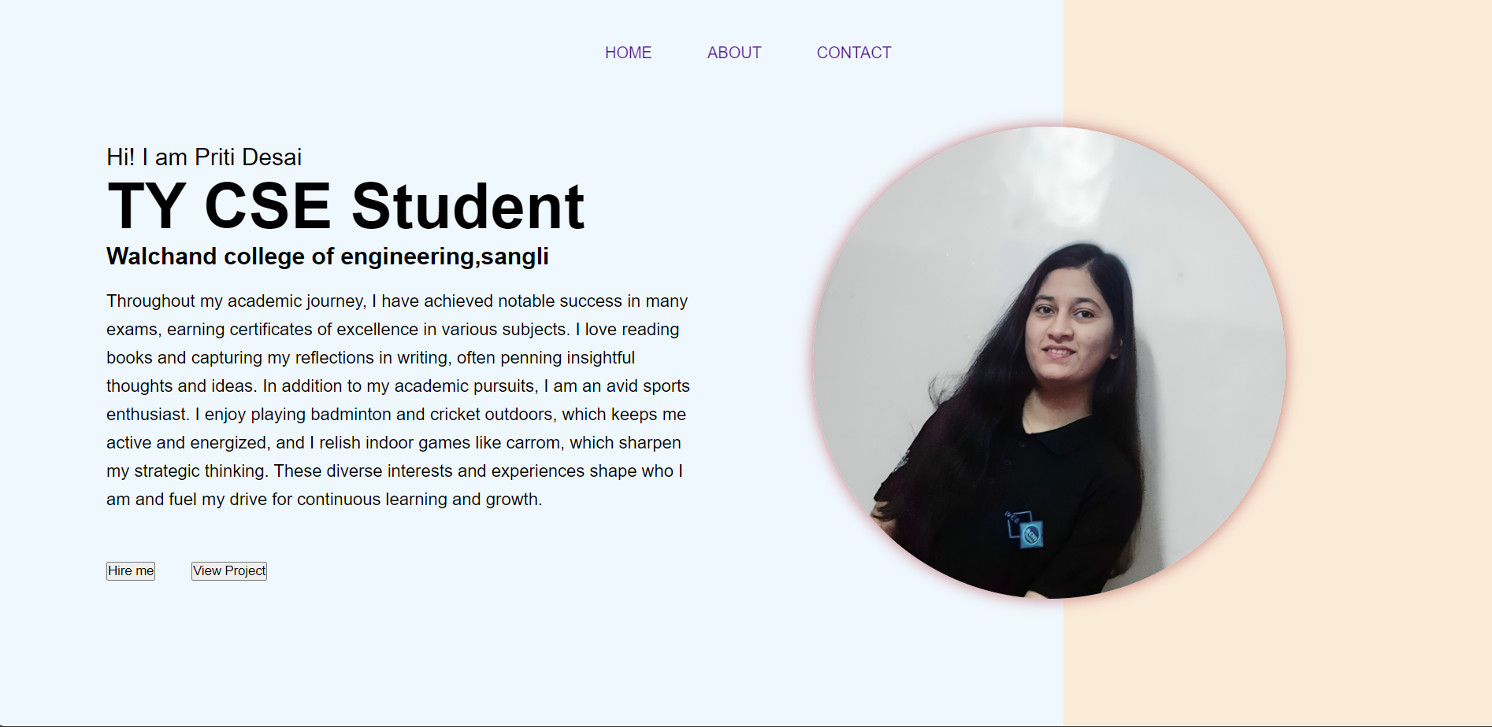

STATEMENT 2

